**Practical No.3**

**Aim**: Write a program in python to scale an image.

**Softwares Used**: Jupyter Notebook, Opencv

**Environment**: python 3.11.2

**Theory** :

Python is a high-level programming language that is designed to be easy to read and write. Python comes with a large standard library that includes modules for various tasks, such as working with regular expressions, networking, and file I/O. This means that you don't have to write code from scratch for every task, as there's likely a pre-existing module you can use. python is dynamically typed, which means that variables don't need to be declared before they are used, and their types can change at runtime.

OpenCV (Open Source Computer Vision) is an open-source computer vision and machine learning software library. It provides a set of tools and algorithms for image and video processing, machine learning, and computer vision tasks. OpenCV is written in C++, but it also has interfaces for Python, Java, and MATLAB.

**Program Code**:

import cv2

import numpy as np

FILE_NAME = 'dolphin.jpg'

try:

# Read image from disk.

img = cv2.imread(FILE_NAME)

# Get number of pixel horizontally and vertically.

(height, width) = img.shape[:2]

# Specify the size of image along with interpolation methods.

# cv2.INTER_AREA is used for shrinking, whereas cv2.INTER_CUBIC

# is used for zooming.

res = cv2.resize(img, (int(width / 2), int(height / 2)),interpolation =

cv2.INTER_CUBIC)

# Write image back to disk.

cv2.imwrite('p3_result.jpg', res)

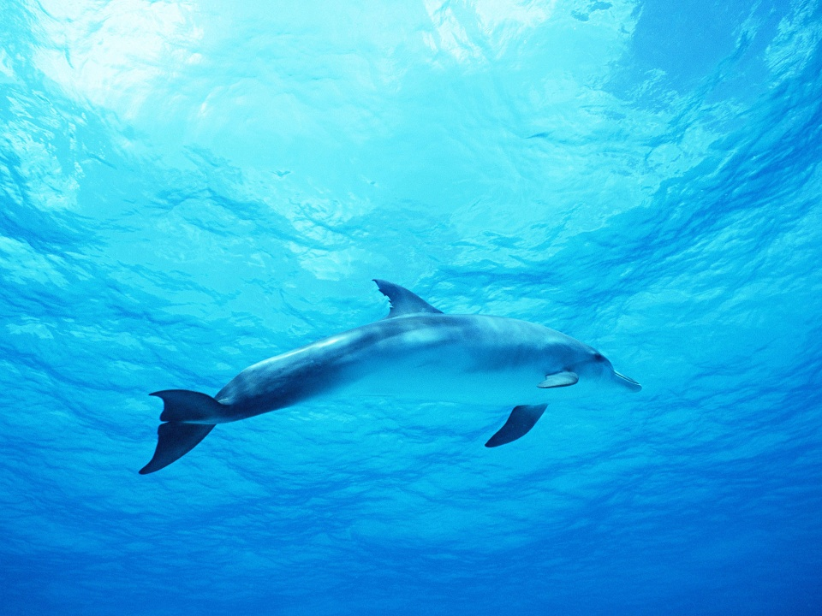**Output**:

4.7.0

True

**Conclusion**: In this practical , we successfully study and implement about to read an image and display in RGB scale using python.